# **Is Buying Google Negative Reviews Illegal?**

Unveiling the dark side of online reputation management, today we delve into a controversial topic: buying negative Google reviews. In a world where digital influence reigns supreme, businesses are constantly searching for ways to boost their image and credibility. But is it ethical – or even legal – to pay for bad reviews on one of the most prominent platforms? Join us as we explore this intriguing phenomenon and shed light on the murky depths of manipulating public perception. Brace yourself because things are about to get interesting!

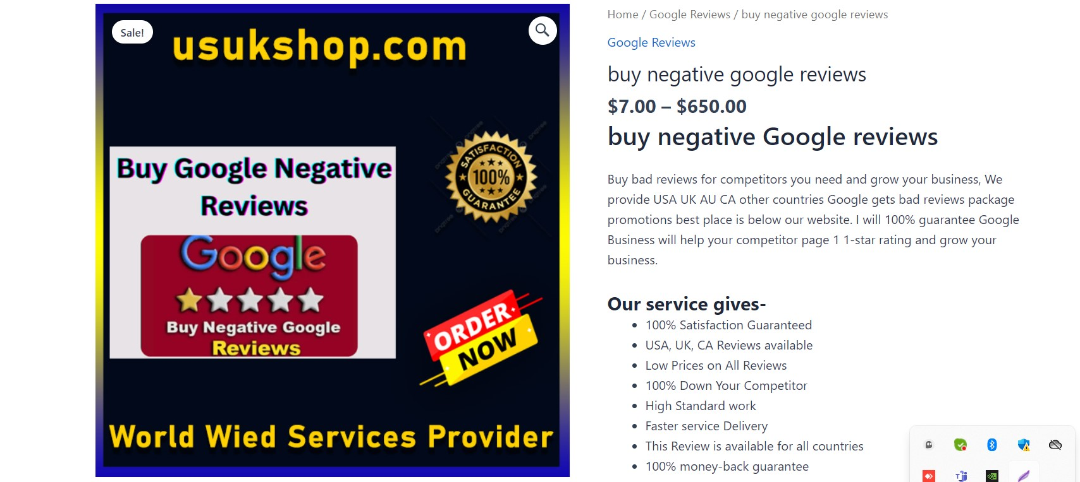

## **Can You Pay for Bad Google Reviews?**

[**Can you pay for bad Google reviews**](https://usukshop.com/product/buy-negative-google-reviews/)? It's a question that may have crossed the minds of some business owners who are looking to sabotage their competitors or simply want to manipulate their online reputation. While it may be tempting to resort to such tactics, it's important to understand the potential consequences and ethical implications.  
  
Let's address the legality of buying negative reviews on Google. The truth is that it varies from country to country and even within different jurisdictions. In some places, paying for fake reviews can be considered deceptive advertising or false representation, which could lead to legal troubles and hefty fines. So, before you consider taking this route, it's crucial to familiarize yourself with the laws in your specific location.  
  
Apart from the legal issues, there are several other reasons why [**paying for bad Google reviews**](https://usukshop.com/product/buy-negative-google-reviews/) might be a poor decision. For one, consumers are becoming increasingly savvy when it comes to spotting fake feedback. If they suspect that your negative reviews are fabricated or insincere, it could severely damage your credibility and trustworthiness among potential customers.  
  
Moreover, search engines like Google have sophisticated algorithms designed specifically to detect fraudulent activities such as review manipulation. If caught engaging in these practices, your website might face penalties ranging from being pushed down in search rankings all the way up to being completely delisted.  
  
Cultivating an authentic and positive online reputation should always be a priority for businesses seeking long-term success. Instead of trying to cheat the system by purchasing negative reviews or resorting to unethical practices like astroturfing (creating fake accounts), focus on delivering exceptional products or services that naturally generate genuine customer feedback.  
  
Remember: honesty is key to building lasting relationships with customers and maintaining a strong online presence. So, while buying negative Google reviews may seem like a quick fix at first glance - tread carefully because when it comes down t

## **How Do I Fake Negative Reviews on Google?**

How Do I Fake Negative Reviews on Google?  
  
While it is never recommended or ethical to engage in fake reviews, some individuals may still be curious about how it could potentially be done. However, it's important to note that fabricating negative reviews on Google can have serious consequences.  
  
One method that people might consider is creating multiple fake accounts and posting negative feedback themselves. This involves setting up new Gmail accounts or using existing ones to leave bad reviews for a business. However, this approach is highly unethical and dishonest.  
  
Another technique some may try is hiring individuals from online platforms like Fiverr to write false negative reviews. These freelancers will create fictional stories and post them as if they were genuine experiences with the business. Not only does this violate Google's terms of service, but it also undermines the credibility of online reviews.  
  
Attempting to manipulate review systems by faking negative feedback not only goes against ethical guidelines but can also lead to severe penalties from Google itself. The search engine giant has strict policies in place designed to combat fake reviews and maintain the integrity of its platform.  
  
Instead of resorting to such deceptive tactics, businesses should focus on providing excellent products and services while actively engaging with their customers for honest feedback. Building a strong reputation based on authentic customer experiences will ultimately yield more positive results than trying to fake negative reviews ever could.

## **Buy Negative Google Reviews Fiverr**

Buy Negative Google Reviews Fiverr  
  
One of the platforms that individuals and businesses turn to when seeking various services is Fiverr. Known for its wide range of freelance offerings, it's no surprise that some people might wonder if they can buy negative Google reviews on this platform.  
  
Fiverr is a marketplace where freelancers offer their services at various price points. While you can find sellers who claim to provide negative Google reviews, it is important to note that engaging in such practices goes against the guidelines set by Google. In fact, purchasing or soliciting fake reviews violates not only ethical standards but also potentially legal ones.  
  
Google takes review authenticity seriously and continuously improves its algorithms to detect and remove fraudulent content. The consequences of buying negative Google reviews can be severe, including penalties such as account suspension or even legal action.  
  
Businesses must build a positive online reputation based on genuine customer feedback rather than resorting to manipulative tactics like buying negative reviews. By providing excellent products or services and encouraging satisfied customers to leave honest feedback, businesses can establish trust with potential clients organically.  
  
Remember, credibility is key in today's digital landscape. Upholding ethical practices will help your business thrive in the long run while ensuring you maintain integrity within your industry sector.

## **FAQs Buying Google Negative Reviews**

FAQs Buying Google Negative Reviews  
  
1. Can You Pay for Bad Google Reviews?  
  
While it is possible to pay someone to leave negative reviews on your competitors' Google profiles, this practice is highly unethical and can have serious legal consequences. Buying bad reviews goes against the terms of service set by Google and many other review platforms, which prohibit fake or misleading content. Additionally, engaging in such practices can damage your reputation and credibility in the long run.  
  
2. How Do I Fake Negative Reviews on Google?  
  
[**Faking negative reviews on Google**](https://usukshop.com/product/buy-negative-google-reviews/) is not only dishonest but also illegal in many jurisdictions. It involves creating false accounts or using VPNs to manipulate the review system artificially. However, these actions are strictly monitored by search engines like Google, which employ sophisticated algorithms to detect fraudulent activities and remove fake reviews from their platform.  
  
3. Buy Negative Google Reviews Fiverr  
  
Fiverr is an online marketplace that connects buyers with freelancers, offering various services, including writing fake reviews for businesses. While you may find sellers who claim they can provide negative reviews on Fiverr, it's important to note that this violates the platform's terms of service as well as ethical guidelines set by reputable SEO professionals.  
  
4. FAQs Buying Google Negative Reviews  
  
Q: Can I get sued for buying negative reviews?  
A: Yes, purchasing negative reviews can result in legal consequences such as defamation lawsuits or violations of consumer protection laws.  
  
Q: Is it worth buying bad reviews for my competition?  
A: No, engaging in unethical practices will ultimately harm your business's reputation and integrity.  
  
Q: Can I trust online review management services?  
A: It is essential to exercise caution when choosing a review management service provider since some companies may engage in black hat tactics that violate policies established by search engines like Google.  
  
In conclusion,  
  
[**Buying Google negative reviews**](https://usukshop.com/product/buy-remove-negative-reviews/) not only violates ethical standards but also has potential legal implications that could harm your business in the long run. Instead of resorting to deceptive practices, it is advisable to focus on providing excellent products or